A PRELIMINARY MINI PROJECT REPORT ON
“Family photo wall: Family vault”

SUBMITTED TOWARDS THE PARTIAL FULFILLMENT OF THE REQUIREMENTS OF
BACHELOR OF TECHNOLOGY (S.Y. B. Tech.)
Academic Year: 2025-26

By:
Arjun Mankuskar (202401110038) Atulya Mishra (202401110051) Vishal Shende (202401110034)

Under The Guidance of

Mr. Anil Pawar


Department of CSE (Artificial Intelligence & Machine Learning) MIT Academy of Engineering
MITAOE Road, Alandi, Pune, 412105

MIT Academy of Engineering

Department of CSE (Artificial Intelligence & Machine Learning)

CERTIFICATE

This is to certify that, the project
“Family photo wall: Family vault” is successfully carried out as a Software Prototyping practical course as mini project idea. In the partial fulfillment of the requirements for the S.Y. B. Tech. (CSE-AIML) successfully submitted by following students of “MIT Academy of Engineering, Alandi, Pune-412105”.
Under the guidance of Mr. Anil Pawar

Arjun Mankuskar (202401110038) Atulya Mishra (202401110051)
Vishal Shende (202401110034)

Project Guide Head of Department
Mr. Anil Pawar Dr. Diptee Ghusee

Chapter No. | Title | Content | Page No.
1 | Introduction | Problem Statement, Objectives, Motivation, Scope | 5
2 | Requirement Analysis | Hardware, Software,  Functional &  Non-Functional Requirements | 7
3 | Design Analysis | UML Diagrams, Architecture, AEIOU Framework | 9-16
4 | Implementation | Prototype Details, Modules, Testing and Results | 17
5 | Results | Screenshots, User Interface Overview, Observations | 19-27
6 | Conclusion | Summary, Future Enhancements | 29

Type | Number | Title / Description | Chapter/Section | Page No. (Inferred)
Table | 1 | INDEX (Table of Contents) | - | -
Table | 2 | Hardware Requirements | 3.1 | 7
Table | 3 | Software Requirements | 3.1 | 7
Figure | 1 | Use Case Diagram (Includes Small and Full Size) | 3.2 | 8-9
Figure | 2 | Class Diagram | 3.3 | 10
Figure | 3 | Activity Diagram (Includes Small and Full Page) | 3.4 | 11-12
Figure | 4 | Sequence Diagram | 3.5 | 13
Figure | 5 | Data Flow Diagram (DFD) | 3.6 | 14
Figure | 7 | Website Images / Screenshots | 5.1 | 18-23

Chapter-1 Introduction

Objective
In today’s modern lifestyle, families are often separated due to work, education, and
personal responsibilities. This physical distance has gradually weakened the emotional bond that once existed through regular interactions and shared experiences. Traditional photo albums, which used to bring families together, have become outdated in the digital age. Although social media platforms allow sharing, they often lack privacy and emotional warmth. The Virtual Family Photo Wall project aims to bridge this gap by providing a secure and private digital space where families can connect, share, and preserve their memories in one place.

Motivation
The main goal of this project is to design an interactive and user-friendly prototype that allows family members to upload, view, and share photographs effortlessly. The system is built to encourage emotional bonding by recreating the nostalgic experience of looking through family photo albums, but in a digital and accessible format. It ensures simplicity, security, and inclusivity so that people of all age groups can easily use the platform. This dedicated environment helps maintain intimate connections while avoiding the distractions and risks of public social networks.

Scope
The project goes beyond simple photo sharing. It aims to evolve into a complete
family-centered platform that supports features like event reminders, shared calendars, and voice message sharing. Future versions may also include artificial intelligence (AI) for automatic photo categorization, face recognition, and memory tagging. The Virtual Family PhotoWall therefore combines modern technology with emotional design, offering a perfect balance between usability, simplicity, and family connection.

Key Points:
- Problem: Families today experience emotional distance due to geographical separation and busy lifestyles.
- Objective: To develop a private and interactive platform that allows families to share and relive memories together.
- Motivation: Existing social media lacks privacy and emotional depth, creating a need for a dedicated family-only space.
- Scope: The system can be expanded with AI features, event reminders, and voice-note sharing to enhance the user experience.

Chapter-2 Requirement Analysis

The development of the Virtual Family Photo Wall prototype required both hardware and software configurations that ensure smooth functioning and accessibility.

2.1 Hardware Requirements
A standard computer or laptop with a minimum of 4GB RAM and an active internet connection is sufficient for designing, testing, and running the prototype. The system is lightweight and can also be accessed easily through smartphones or tablets, providing flexibility and portability for users of all age groups.

2.2 Software Requirements
For the software setup, web technologies such as HTML, CSS, and JavaScript are used to design the frontend interface, ensuring a clean and interactive user experience. The backend can be implemented using Python (Flask/Django) or Node.js for handling data communication and managing user operations. To store and organize uploaded photos, user information, and captions securely, databases such as MySQL or Firebase are utilized. Design tools like Figma and Canva are also used to create an intuitive and visually appealing layout for the prototype.

2.3 Functional and Non-Functional Requirements
The application includes essential functional features like user registration, login, photo uploading, and album viewing, making it simple yet effective.

Apart from functional features, the system is also designed with important non-functional requirements in mind:
    - Security: Ensures that all user data remains private.
    - Scalability: Designed to handle a growing number of users and media files.
    - Usability: Provides a smooth and engaging experience across multiple devices.

The overall goal is to create a platform that is reliable, easy to navigate, and accessible for everyone in the family, from children to elderly members.

Chapter-3 Design Analysis

3.1 Hardware, Software Resources, Requirements & Their Detailed Explanation
The design and development of the Virtual Family Photo Wall prototype required both hardware and software components that ensured smooth operation, scalability, and ease of prototyping. The system was designed to be lightweight so that it can run efficiently on commonly available hardware without demanding high-end configurations.

Hardware Requirements:

Component | Specification | Purpose
Processor | Intel Core i3 or higher | For smooth performance during design and execution
RAM | Minimum 4 GB | Ensures efficient multitasking and tool performance
Storage | 500 GB or higher | To store project files, designs, and prototype data
Internet Connection | Stable Wi-Fi or LAN | Required for cloud access and collaboration
Smartphone / Tablet | Optional | To test mobile accessibility and user experience

Table- 3.1.1
Software Requirements:
Software Tool | Purpose / Description
Framework: Next.js | This allows for a mix of server-rendered and client-side components for better
Language: TypeScript | This adds type safety to our JavaScript code, preventing many common bugs.
Backend: | We're using several of its services:  Firebase Authentication for user sign-in (Email/Password and Google).  Firestore as our real-time database for storing user profiles, family data, and photo metadata.  Firebase Storage to securely store the uploaded photo
Image Uploads: Cloudinary | for handling direct client-side image
Generative AI: Genkit | Genkit with Google's Gemini model to power the "theme suggestion" feature.
ShadCN UI | This provides us with a set of well-designed, accessible, and customizable components like Cards, Buttons, Dialogs, and Inputs.
Table-3.1.2
3.2 Use Case diagram

The Use Case Diagram represents the key users of the system and how they interact with its main functionalities. It provides a clear understanding of how different actors communicate with the system to perform specific operations within the Virtual Family
Photo Wall platform.

In this system, the main actors are:
    - Family Members: Regular users who can upload, view, and comment on photos.
    - Family Head (Admin): Responsible for managing the family wall, approving members, and organizing albums.
    - Distant Relatives: Invited users who can view photos and participate in shared events or celebrations.
The major use cases include:

    - Uploading, viewing, and deleting photos.
    - Adding captions or short descriptions to memories.
    - Sending invitations to join the family wall.
    - Creating and managing celebration walls for special occasions.
    - Organizing albums and browsing shared memories.
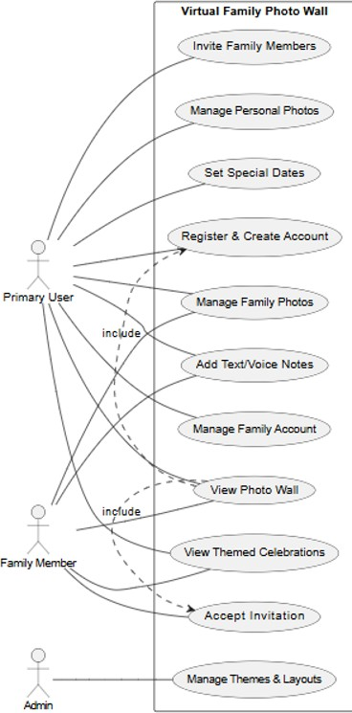

Figure- 3.2.1- Small Use Case Diagram
Figure- 3.2.2- Full Use Case Diagram

3.3 Class Diagram

The Class Diagram illustrates the structural design of the Virtual Family PhotoWall system using object-oriented design principles. It identifies the core classes, their key attributes, operations, and the relationships that connect them. This diagram helps in understanding how different components of the system work together to provide the required functionality. Each class in the system has a specific purpose and responsibility, contributing to a modular and organized architecture.

The major classes included in the design are:
    - User Class: Handles all user-related information such as user ID, name, email, password, and relationship type (e.g., parent, child, relative). It manages user authentication and access control.
    - Photo Class: Responsible for managing image files, captions, upload date, and storage paths. It ensures that each photo is linked to a specific user and album.
    - Album Class: Groups multiple photos together based on themes, events, or family members. It maintains album names, creation dates, and associated members.
    - Memory Class: Represents shared moments and posts, including captions, comments, and emotional tags. It allows users to relive and interact with memories.
    - Database Handler Class: Acts as the communication layer between the frontend and the backend. It manages database connectivity, queries, and data
storage/retrieval operations.

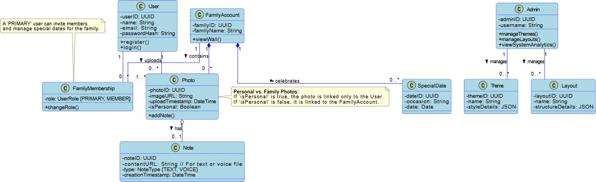

Figure- 3.3.1- Case Diagram

3.4 Activity Diagram

The activity diagram represents the overall workflow and interaction between the user and the Virtual Family Photo Wall system. It visually depicts the sequence of actions, decision points, and flow of control that occur during user operations. The diagram helps to understand the system’s dynamic behavior by outlining how processes are executed from start to finish. In the Virtual Family PhotoWall, the activity diagram highlights key actions such as logging in, uploading photos, viewing memories, and managing albums. It ensures that all user interactions are logically structured and executed in a smooth, efficient manner.

An example of the Photo Upload Process is described below:

- The user opens the application and logs into the system.
- The system verifies the entered credentials for authentication.
- After a successful login, the dashboard is displayed with available options such as “Upload Photo” or “View Album.”
- The user selects the upload option and chooses a photo from their device.
- The system validates the input and stores the image along with details like captions and timestamps in the database.
- A confirmation message is displayed to the user.
- Finally, the updated photo wall is shown, reflecting the newly added memory.
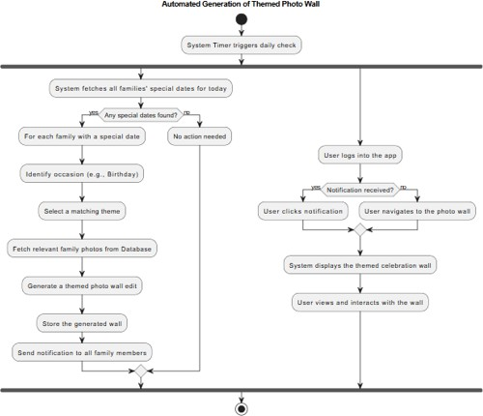

Figure – 3.4.1-Small Activity Diagram

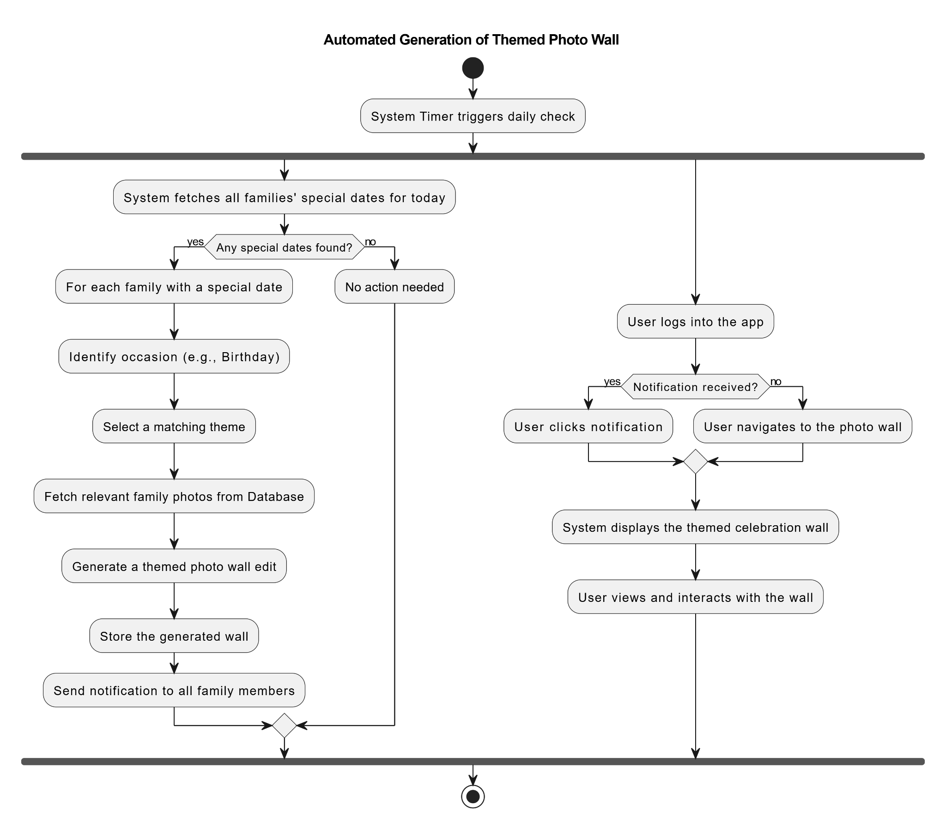
Figure- 3.4.2- Full Activity Diagram

3.5 Sequence Diagram

The Sequence Diagram illustrates the step-by-step interaction between different system objects during key processes in the Virtual Family Photo Wall. It focuses on the order of communication and method calls that occur when users perform specific actions, such as uploading photos, managing albums, or inviting new family members. This diagram helps in understanding how data flows through the system by showing how each component interacts over time. It provides a clear view of how the frontend, backend, and database work together to complete user requests efficiently.

For example, in the Photo Upload Sequence:

- The User initiates a request to upload a photo.
- The System Interface captures the photo and related details such as captions or tags.
- The Application Logic processes the data and validates the file format.
- The Database stores the uploaded photo and metadata securely.
- The System sends a success message back to the User, confirming the upload.

Similarly, during the Invite Family Member process:

- The User selects “Invite Member.”
- The System sends an invitation request via email or in-app notification.
- The New Member receives and accepts the invitation.
The Database updates the member list and permissions.

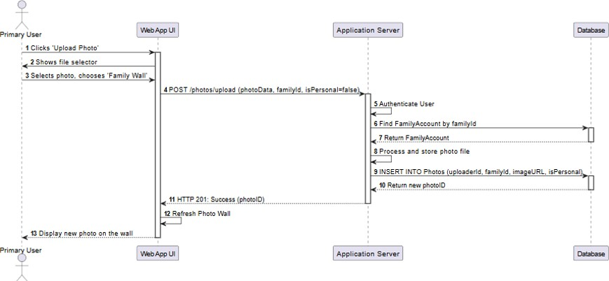
Figure-3.5.1-Sequence Diagram

3.6 Data Flow Diagram (DFD)

The Data Flow Diagram (DFD) provides a clear visualization of how data moves within the Virtual Family Photo Wall system. It illustrates the flow of information between various system components, including users, processes, and the database. The DFD helps to understand how data is input, processed, stored, and retrieved across the platform. In this system, the DFD highlights core operations such as user registration, login authentication, photo uploads, and memory viewing. It represents how each of these processes interacts with the central database to maintain data consistency and security.
The Level 0 DFD (Context Diagram) shows the entire system as a single process interacting with external entities like Family Members and Admin. Users send requests such as uploading or viewing photos, and the system responds by retrieving or storing relevant data.
The Level 1 DFD further breaks down these processes into smaller components:

- User Registration and Login: Validates user credentials and manages authentication.
- Photo Upload Process: Accepts image files and metadata from users, then stores them in the database.
- Album Management: Organizes uploaded photos into albums or event categories.
4. Photo Viewing and Sharing: Fetches stored images and displays them on the family wall.
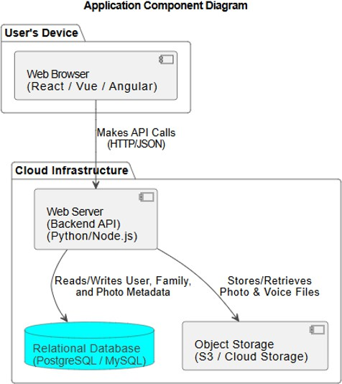

Figure- 3.6.1- Application Component Diagram

3.7 System Architecture

The Virtual Family Photo Wall system is designed using a three-tier architecture, which includes the frontend, backend, and database layers. Each layer has a specific role in ensuring that the system functions smoothly, securely, and efficiently.

Frontend (Presentation Layer)
The frontend is the part of the system that interacts directly with the user. It is developed using HTML, CSS, and JavaScript, providing a clean and simple interface for uploading photos, viewing albums, and managing user profiles. The design focuses on ease of use and accessibility so that users of all age groups can comfortably navigate the application. It is also responsive, ensuring smooth performance across desktops and mobile devices.

Backend (Application Layer)
The backend acts as the bridge between the user interface and the database. It is implemented using Python (Flask/Django) or Node.js, which handle user requests, manage sessions, and process data. The backend is responsible for authentication, uploading and retrieving photos, and maintaining communication with the database. It ensures that all operations are executed securely and efficiently.

Database Layer
The database layer is responsible for storing all system data, including user details, uploaded photos, captions, and timestamps. MySQL or Firebase is used for secure and efficient data management. The database ensures that all information is organized, easily retrievable, and protected from unauthorized access.

Chapter-4 Implementation

The implementation phase of the Virtual Family Photo Wall focused on converting design concepts into a functional prototype that demonstrates how the system will work in real time.

The prototype was created using Figma and Canva, which provided flexibility and ease in designing visually appealing and interactive user interfaces. The interface includes essential screens such as the Login Page, Dashboard, and Upload Window. Family members can log in, upload photos, write captions, and view shared memories effortlessly. The Dashboard acts as a central wall that displays all uploaded photos in chronological order, recreating the nostalgic feel of flipping through an old family album. Each module — including photo upload, album browsing, and event wall creation — is designed with simplicity, clarity, and accessibility in mind, ensuring that users of all ages can easily navigate the system.
During the prototype testing phase, multiple users interacted with different screens and provided valuable feedback. Their responses confirmed that the system was intuitive, responsive, and emotionally engaging. The layout, color palette, and smooth transitions were particularly appreciated for creating a sense of warmth and nostalgia. The user-centered design approach ensured that every visual element and interaction supported the project’s goal — to foster emotional connection among family members through a shared digital experience.

Overall, the implementation successfully demonstrates how the Virtual Family Photo Wall could function as a real-world application. The prototype not only validates the design and usability goals but also lays a strong foundation for future development into a fully operational web or mobile platform.

Chapter-5 Results

The Virtual Family Photo Wall prototype successfully delivers both a functional and emotionally engaging user experience. The interface consists of screens such as Login, Registration, Upload, and Celebration Wall, all designed with simplicity and warmth. Each element has been thoughtfully developed to ensure users can interact comfortably, regardless of age or technical background.

The overall design follows a soft and welcoming visual theme, using warm color tones, rounded shapes, and intuitive navigation to make the system feel natural and nostalgic. The timeline-based display of photos allows users to view their memories chronologically, resembling a digital family album.
This approach effectively enhances the emotional connection between users and their shared memories.

During testing, users appreciated the prototype’s simplicity and layout. They found the system easy to understand and navigate, even without prior instruction. The positive feedback confirmed that the project meets its main objectives — simplicity, usability, emotional engagement, and connectivity.
The results validate that the Virtual Family Photo Wall can become a reliable and meaningful platform for families to share memories, celebrate moments, and stay emotionally connected in today’s digital world

Website Images
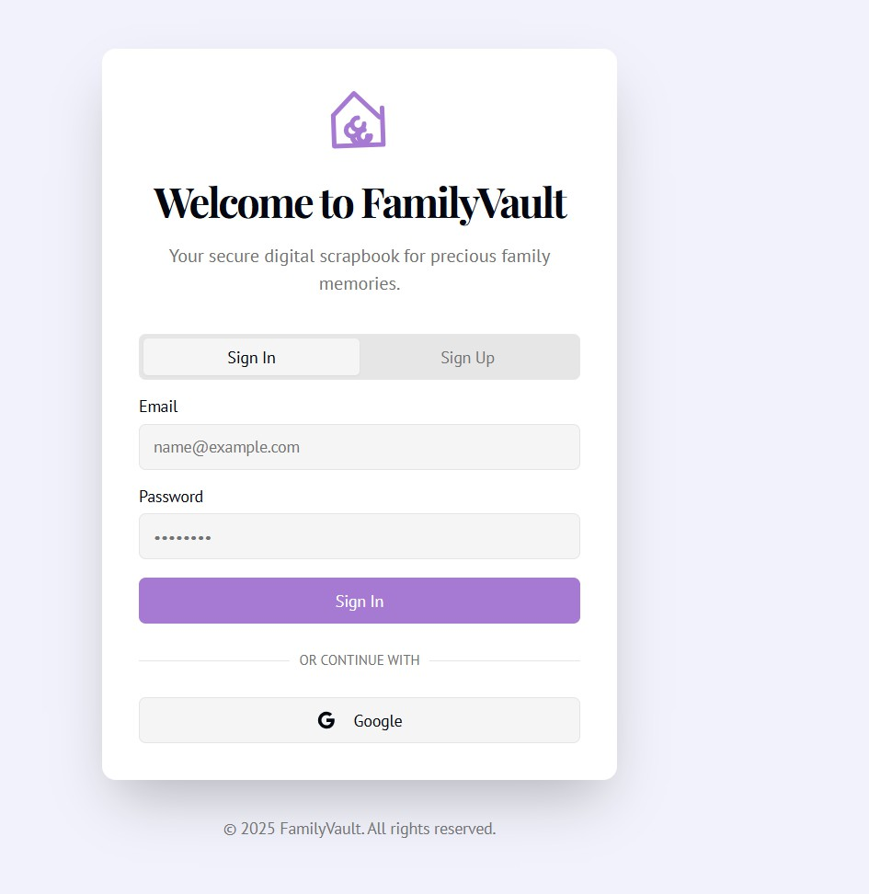

Figure- 5.1.1- It shows the signin or signup page.

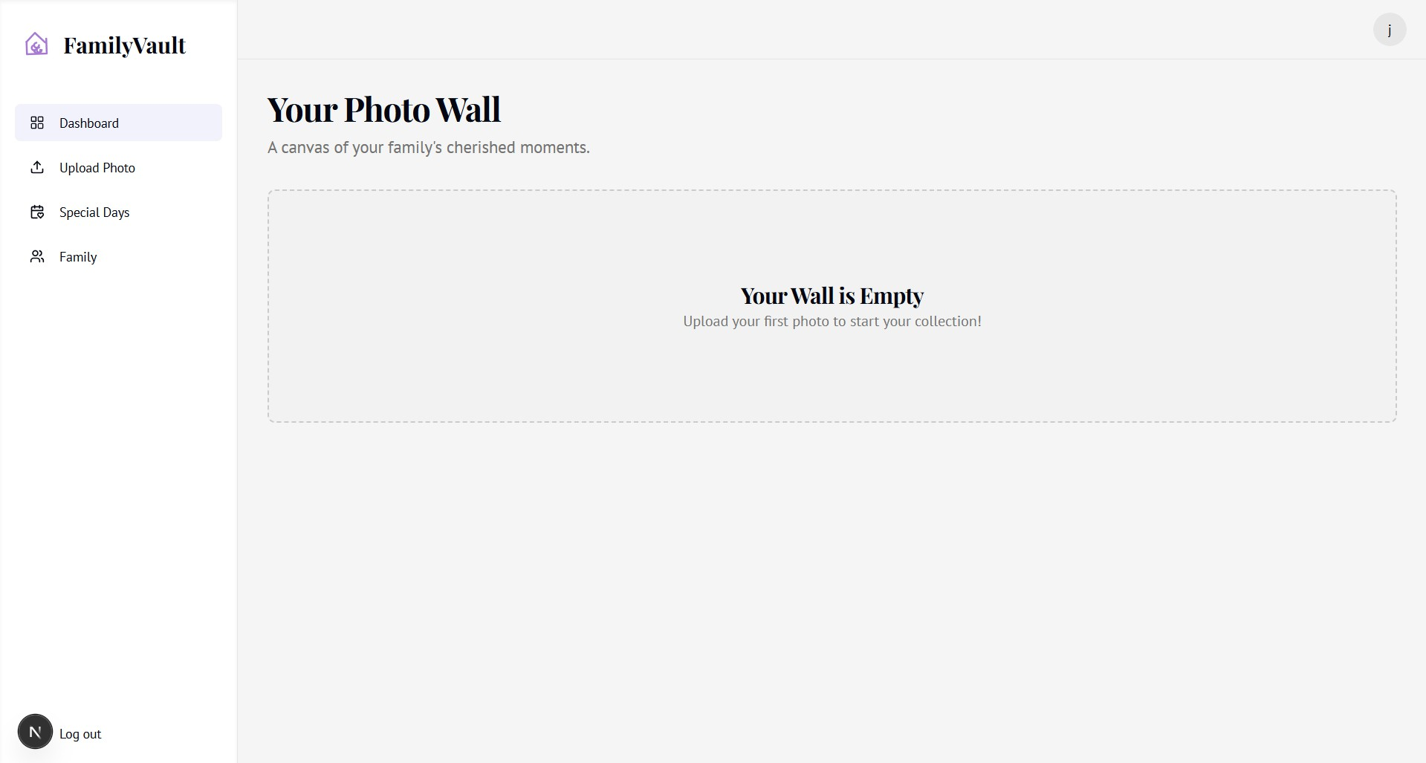

Figure- 5.1.2- It shows a empty dashboard a person gets to this page after logging in.

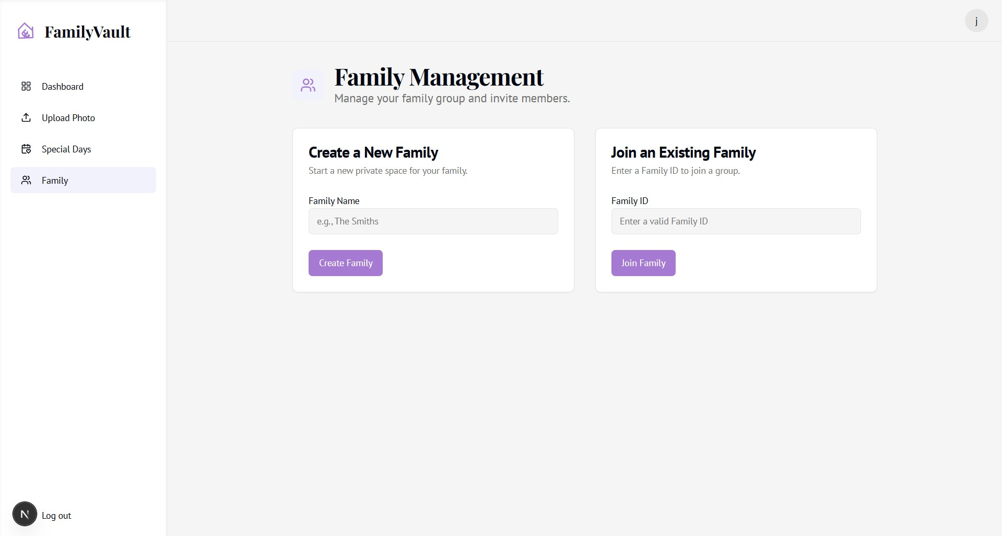

Figure- 5.1.3- It shows that the person after logging has two options of choosing to create a family or joining a family.

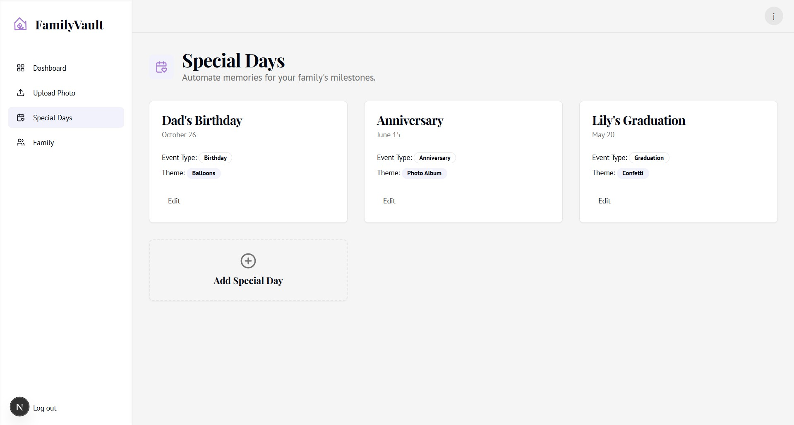
Figure- 5.1.4- It shows that the family members can add the special days like birthdays, anniversary in the web app.

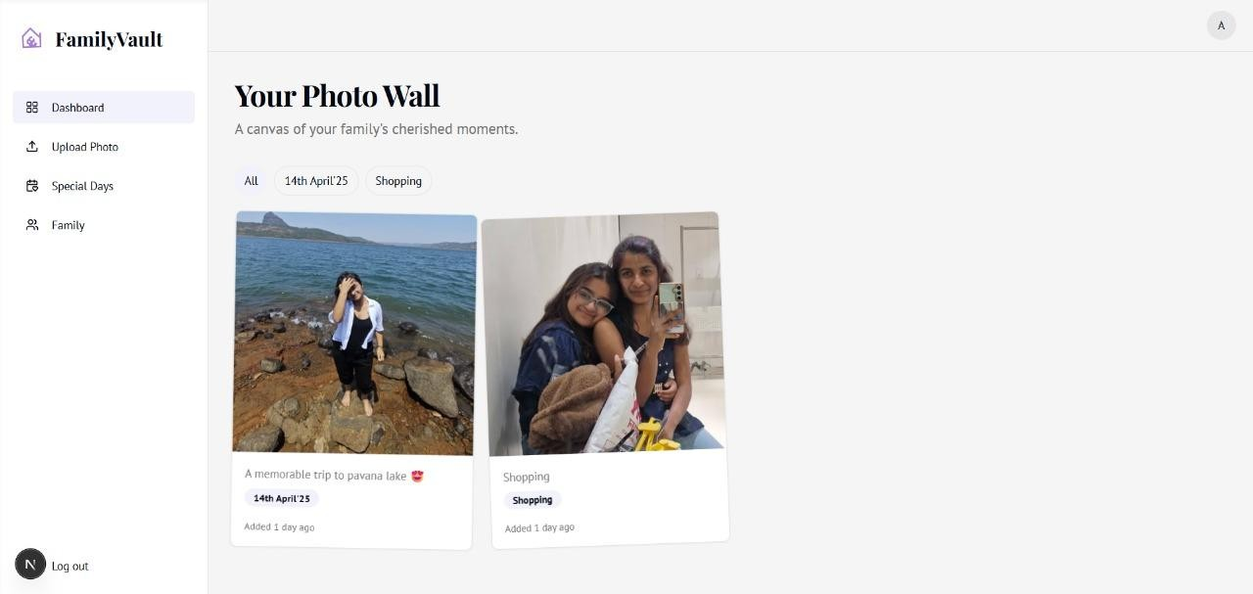

Figure- 5.1.5- It shows the common family dashboard in which the photos are uploaded by different family members.

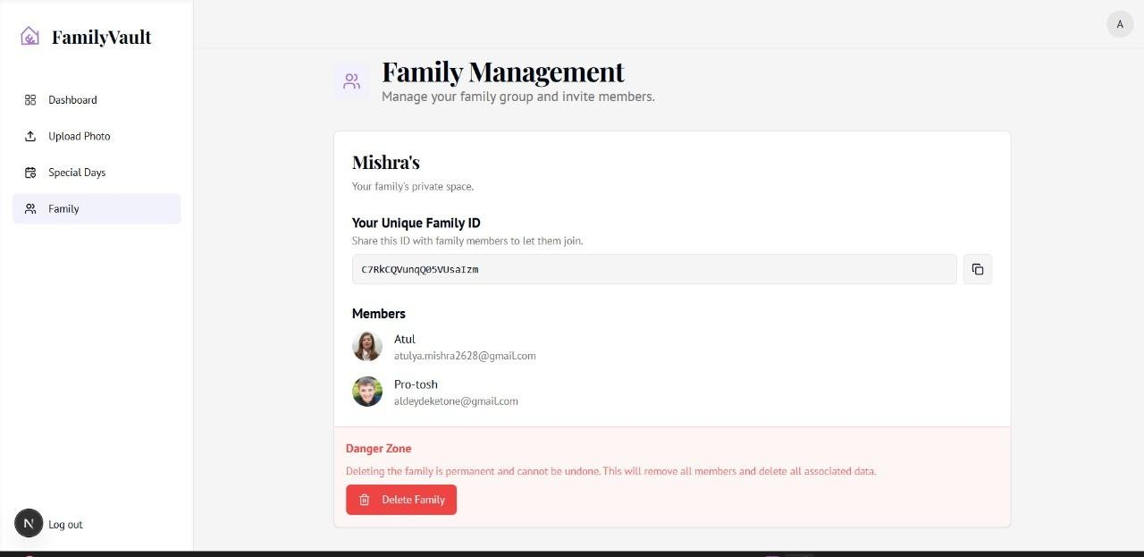

Figure-5.1.6- It shows the unique family Id which is used to connect to the common family dashboard.

Chapter-6 Conclusion

The Virtual Family Photo Wall prototype successfully fulfills its purpose of fostering
emotional connections among family members through digital means. It demonstrates how technology can be used not just for communication, but for emotional preservation
and family bonding. By combining thoughtful design with simple functionality, the system creates a private and user-friendly platform where family members can securely store and share memories. The project achieves its core goals — usability, privacy, and emotional engagement — while showcasing the potential of technology to bring people closer together. The design encourages users to relive memories, celebrate special occasions, and maintain relationships despite physical distance.

Looking ahead, the Virtual Family Photo Wall has significant potential for further development. Future versions can include features such as mobile app integration, cloud-based storage, AI-powered photo categorization, and voice-note sharing, making the system more dynamic and interactive.

In conclusion, this project represents a small yet meaningful step toward blending technology and emotion, creating a digital space that strengthens family connections and preserves cherished memories for generations to come
REFERENCES

1. Firebase Documentation. Firebase: Build and Run Successful Apps. Available at: [https://firebase.google.com/](https://firebase.google.com/)

2. Next.js Documentation. Next.js – The React Framework for the Web. Available at: [https://nextjs.org/](https://nextjs.org/)
3. Cloudinary Documentation. Cloudinary Image & Video API. Available at: [https://cloudinary.com/documentation](https://cloudinary.com/documentation)
4. Genkit by Google. Genkit AI Framework. Available at: [https://github.com/google/genkit](https://github.com/google/genkit)
5. UML Diagrams– UML Diagram Guide. Available at: [https://www.lucidchart.com/pages/uml-diagram](https://www.lucidchart.com/pages/uml-diagram)

Plagiarism



Website Link :-https://family-vault-project.vercel.app/

QR code:-

